Format of Russian Polish Birth Records
Some are gif images and not too clear.
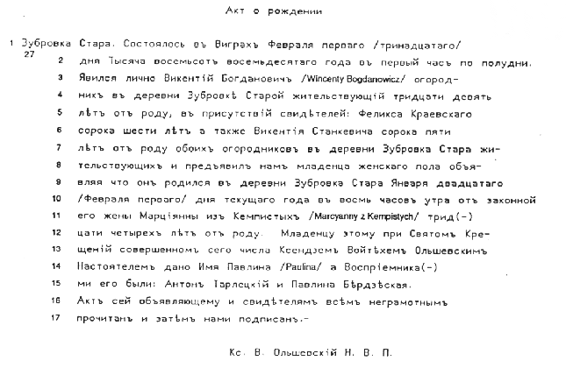
Birth Record

1 Zubrovka Stara. It happened in Vigry the first /the thirteenth/ of February 27

2 the one thousand eight hundred eightieth year, in the first hour after noon,

3 (that) Vikenti Bogdanovich (Wicenty Bogdanowicz), market gardener

4 residing in the village Zubrovka Stara, age thirty-nine,

5 presented himself personally in the presence of the witnesses:Felika Kraevskii

6 forty-six years, and likewise Vikenti Stankevich, forty-five

7 years, both market gardeners in the village Zubrovka Stara,

8 and showed us an infant of female gender, declaring

9 that it was born in the village Zubrovka Stara on the twentieth of January

10 /the first of February/ of the current year at eight o'clock in the morning, by his

11 lawful wife Marcyanna né Kempista (Marcyanna z Kempistych), age thirty-four.

12 To this infant, through Holy Christening

13 performed this date by the priest Voitekh Ol'shevskii,

14 dean, was given the name Pavlina (Paula), and the godparents

15 were: Anton Tarletskii and Pavlina Berdzeskaya.

16 This record was read to the informant and the witnesses, all illiterate,

17 and then signed by us.

Priest Voitekh Ol'shevskii, D.V.P. (dean of Vigry parish)

